 

­

**Web Application Development**

Team 4

MEMBERS:

* Pardo Rómulo
* Pila Nataly
* Pilligua Washington
* Romero Cristhian

Theme:

Client - Server Web Development

**Activity 3**

Tutor:

PhD. JORGE EDISON LASCANO Mgs

**ACTIVITY #3**

Home page mockups called index.

***Figure 1.***

*Home page mockup interface (index).*

Note. Own elaboration by team 4 in Lucidchart

Link: [https://lucid.app/lucidchart/b620cc37-0a64-4e14-b662-b498cd90ff7d/view#](https://lucid.app/lucidchart/b620cc37-0a64-4e14-b662-b498cd90ff7d/view)

***Figure 2.***

*Home page interface (index).*

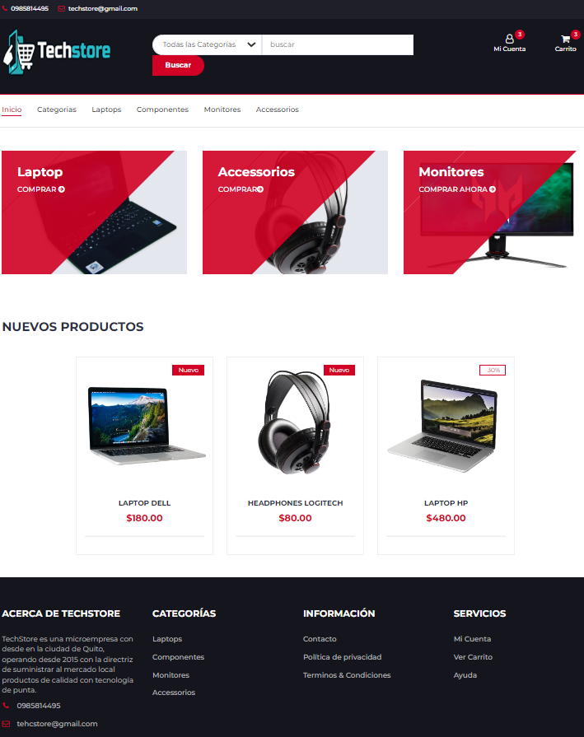

Note. Own elaboration by team 4 in Lucidchart

***Figure 3.***

*Home page mockup interface (login).*

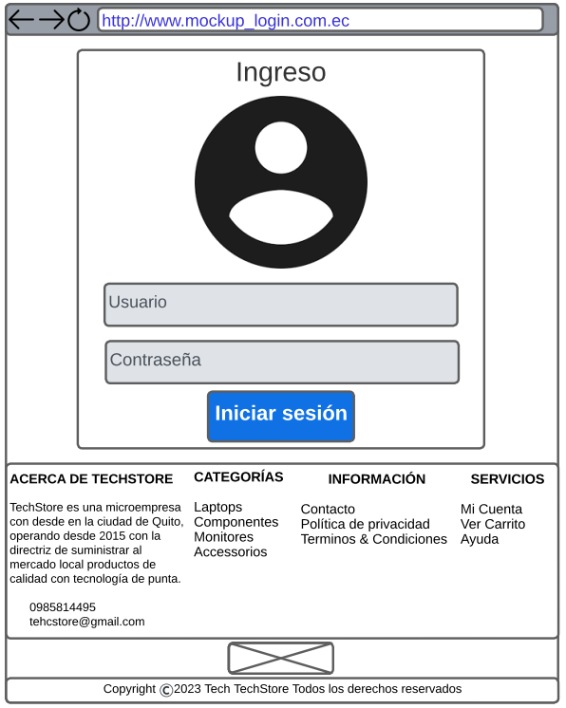

Note. Own elaboration by team 4 in Lucidchart

Link: [https://lucid.app/lucidchart/929872bb-0d45-40e4-b471-790e5f61a99e/view?page=0_0#](https://lucid.app/lucidchart/929872bb-0d45-40e4-b471-790e5f61a99e/view?page=0_0)

***Figure 4.***

*Home page mockup interface (register).*

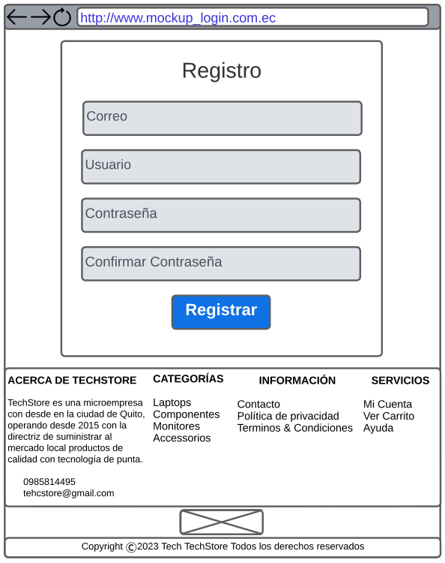

Note. Own elaboration by team 4 in Lucidchart

Link: <https://lucid.app/lucidchart/add0dee5-851b-4473-9899-e70d44e464b1/view?page=0_0>

***Figure 5.***

*Home page mockup interface (register product).*

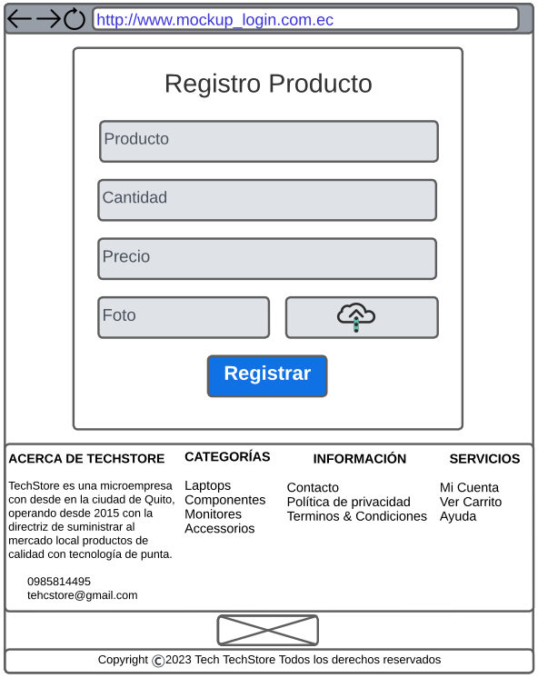

Note. Own elaboration by team 4 in Lucidchart

Link: <https://lucid.app/lucidchart/442fd2f5-3a70-4777-9a04-d19298e7b5b8/view?page=0_0>

***Figure 6.***

*Home page mockup interface (clients).*

Note. Own elaboration by team 4 in Lucidchart

Link: [https://lucid.app/lucidchart/2922aac0-6423-4e74-9138-31538453a2ad/view?page=0_0#](https://lucid.app/lucidchart/2922aac0-6423-4e74-9138-31538453a2ad/view?page=0_0)

***Figure 7.***

*Home page mockup interface (register client).*

Note. Own elaboration by team 4 in Lucidchart

Link: [https://lucid.app/lucidchart/debf2fe8-bcd1-4dcc-9baf-10b35357cc3b/view?page=0_0#](https://lucid.app/lucidchart/debf2fe8-bcd1-4dcc-9baf-10b35357cc3b/view?page=0_0)

***Figure 8.***

*Home page mockup interface (register vendor).*

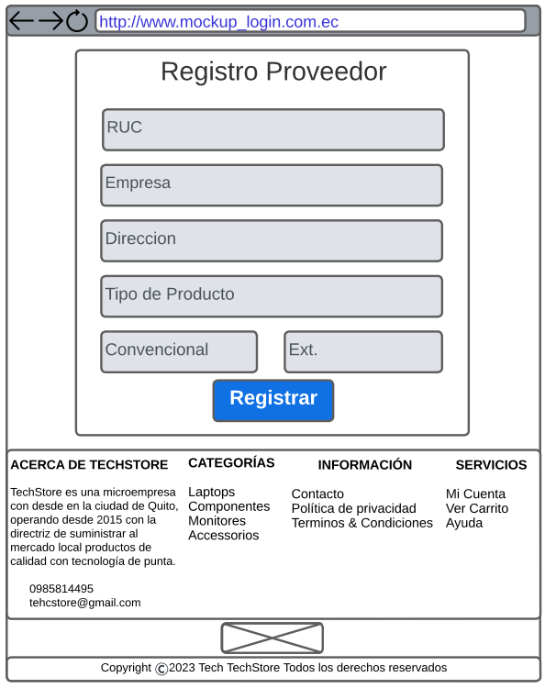

Note. Own elaboration by team 4 in Lucidchart

Link: [https://lucid.app/lucidchart/1355b956-b3b9-4c2d-bb66-fc65d9be2b2e/view?page=0_0#](https://lucid.app/lucidchart/1355b956-b3b9-4c2d-bb66-fc65d9be2b2e/view?page=0_0)